Type of the Paper (Article)
Diversity of fish and mobile epibenthos on reefs and sandbanks in the Bulgarian Black Sea NATURA 2000 site Ropotamo
Marina Panayotova ¹, Valentina Todorova ¹ and Ivelina Zlateva ,*
Academic Editor: Firstname Lastname
Received: date
Revised: date
Accepted: date
Published: date
Copyright: © 2026 by the authors. Submitted for possible open access publication under the terms and conditions of the Creative Commons Attribution (CC BY) license.
¹ Institute of oceanology – Bulgarian Academy of Sciences, “Parvi mai” 40 Str., P.O.Box 152, 9000 Varna, Bulgaria; mpanayotova@io-bas.bg, vtodorova@io-bas.bg, i.zlateva@io-bas.bg
* Correspondence: mpanayotova@io-bas.bg

Abstract
The present study examines the community diversity of the bentho-pelagic fish and the mobile epibenthos assemblages in relation to the substrate type and the depth range on reefs (1170) and sandbanks (1110) at the Natura 2000 site Ropotamo, the Bulgarian Black Sea. Data on species composition and abundance were collected at 18 sites using stationary gillnets. Habitat-related community patterns were examined comparatively on rock, sand and coarse sediment by hierarchical cluster analysis and multidimensional scaling of similarity. Altogether 23 fishes, 7 decapod crustaceans and 2 gastropods were identified, belonging to 22 families. The substrate type was recognised as the key factor driving the communities’ composition, diversity and abundance. Diversity indices were significantly higher on rocky bottom, while catch per unit effort in number and biomass attained the highest value on sandy bottom. The study results provide baseline for monitoring of the marine protected area effects on fish and epibenthos diversity.
Keywords: fish assemblages, mobile epibenthos, diversity, Black Sea, Habitats Directive, habitat types 1110 and 1170
Key Contribution: The breakthroughs or highlights of the manuscript. Authors can write one or two sentences to describe the most important part of the paper.

1. Introduction
The habitat structure plays an important role in the process of animal communities’ establishment and continuity. Marine organisms are associated with particular habitats which provide the resources essential for their growth, survival and reproduction and thus determine the biological communities’ composition, structure and abundance. The community diversity of the marine fishes and the benthic invertebrates depends on a number of physical, chemical and trophic conditions that overall constitute the habitat, but could also be affected by anthropogenic activities and pressures such as contamination, eutrophication, fisheries, man-made structures in the coastal zone, etc. [1, 2, 3].
The Black Sea comprises a variety of coastal marine habitats, which are highly sensitive to anthropogenic pressure due to the peculiarities featured by the Black Sea ecosystem: a semi-enclosed basin with a vast drainage area five times greater than the sea surface, high productivity, permanent density stratification of the water column and permanent anoxic conditions below depth 120-150 m [4, 5, 6]. Excessive commercial fishing in the shelf area has exerted significant pressure on both the fish stocks and the seabed habitats in the Black Sea since the 1970-ties (Prodanov et al. 2007; Zaitsev et al. 1992; Boltachev 2006). Habitat loss and degradation, and overfishing have become critical ecological problems in the Black Sea that have resulted in long-term decline in the species abundance and diversity (TDA 2007; Todorova et al. 2021). Marine protected areas (MPAs) are broadly viewed as a tool for biodiversity protection and restoration, widely used to prevent overfishing as well. In Bulgaria, the process of designating MPAs has been carried out mostly in the frame of the European ecological network NATURA 2000. Bulgaria has already designated an overall of 17 sites of community importance (SCIs) under the Habitats Directive, which comprise parts of both marine and terrestrial environment and only 13 of them have been adopted as special area of conservation (SACs) by order of the Minister of the Ministry of Education, Culture and Science till the end of 2023. The total area of marine waters included in Natura 2000 amounts to 2 476.8 km².
Although the studies on fish and zoobenthos diversity in the Bulgarian Black Sea are relatively plentiful (see reviews by Stoyanov et al. 1963; Marinov 1990; Konsulov 1998; Karapetkova and Zivkov 2006; Golemanski 2007; Stefanov 2007), specialised studies are deficient on the fish assemblages and the mobile epibenthos associated with the habitat types 1110 Sandbanks which are slightly covered by sea water all the time and 1170 Reef listed in the EC Habitat Directive Annex 1. In the recent Red Book of Republic of Bulgaria (2015), based on review of the available national literature, Todorova and Panayotova (2015a, 2015b) provide summarized information on the typical fish and zoobenthos species occurring in the sandy and rocky habitats of national conservation importance.
The current research represents as a pilot case study conducted in the Bulgaria Black Sea, focusing on the co-occurrence of two ecological groups: bentho-pelagic fishes and large mobile benthic epifauna. This study endeavors to compare the diversity and abundance of these communities across reefs (1170) and sandbanks (1110) within the confines of the Special Area of Conservation (SAC) Ropotamo (BG0001001). This evaluation was conducted through the utilization of diversity metrics, as well as analyses pertaining to community similarity and community ecology.

2. Materials and Methods
Study area
The study area was located in the coastal zone of SAC Ropotamo along the Bulgarian Black Sea coast (Figure 1). The SAC Ropotamo encompasses a marine region of 882.387 km2, which extends to depths of up to 75 m. The coastal seabed exhibits a diverse range of substrates, including rocky outcrops and biogenic oyster reefs ranging in height from 3 m to 10 - 15 m. Additionally, the seabed consists of sand and coarse sediments, as depicted in Figure 1 (EUSeaMap, 2021). The reefs and sandy bottoms are distributed unevenly near the shore, extending to a depth of approximately 40 meters.

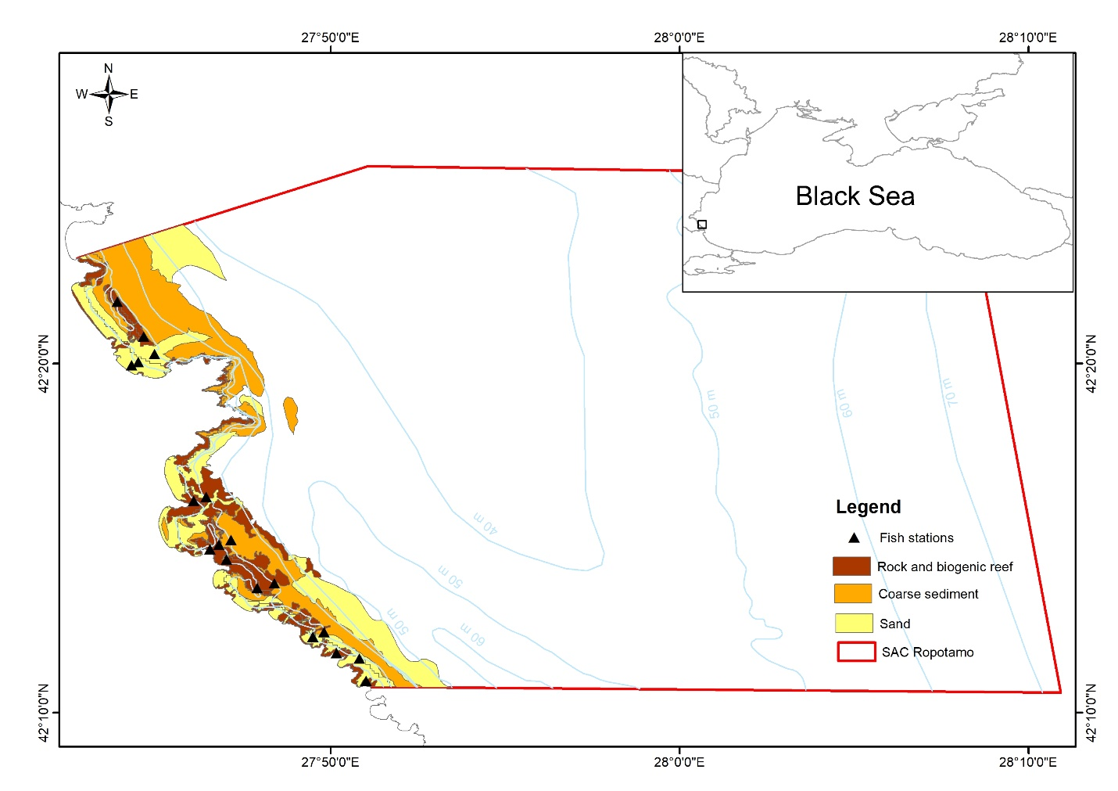
Figure 1. Map of the study area, substrates (according to EUSeaMap 2021), and sampling stations in the SAC Ropotamo, Bulgaria

Sampling methods
The sampling was conducted from 22 to 29 June 2013 using monofilament fishing gillnets with a mesh size of 22 x 22 mm, a length of 100 m, and a height of 1 m. The nets were deployed on a small fishing boat at eighteen locations, chosen to be representative of different types of substrates. Specifically, five locations were on sand, ten were on rock, and three were located on coarse sediments. The sampling depths ranged from 2 to 30 meters (Figure 1). The gillnets were positioned in a parallel manner to the shoreline and secured to the seabed using anchors at both ends. At each sampling location, a single gillnet was set up and left overnight for a minimum of 12 hours to ensure that the period of highest fish and epibenthos activity was covered.
The fish and benthic invertebrates caught were identified in situ to the species level, weighed, and counted. Generally, various alternative gears for collecting samples of the fish population and mobile species living near the seabed in shallow coastal waters are available. These include gill nets with large and medium-sized mesh, pots, and trawl nets. However, these techniques were not used in order to prevent unnecessary adverse effects on organisms in the protected area. Sampling during the later part of spring ensured the presence of migratory species in the area.

Statistical analyses
Prior to conducting spatial analysis, the raw data on the abundance and biomass of each species at different stations were standardised to represent the number of individuals and biomass (in kg) per 100 m2 of net per day (24 hours). The standardized abundance data was used in the computation of three common diversity metrics: Species richness (S), which refers to the total number of species in a community. Shannon-Wiener diversity (H') takes into account both the abundance and evenness of the species present: $H^{'}=-\sum_{i=1}^{S}{p_{i}\log_{2}\left(p_{i}\right)},$ where: S – is the total number of species in the sample; $p_{i}=n_{i}/N,$ where – abundance of i-th species, N – total abundance of all species in the sample; and Pielou’s evenness (J) - measure of the degree to which the abundances are divided evenly among the present species: $J =\frac{H^{'}}{ln\left(S\right)},$, where H' is Shannon-Weiner diversity and S is the total number of species in a sample, across all samples in the dataset.
The frequency of occurrence (FO) by species was calculated.
The characterization of assemblages in various habitats was conducted using the Catch per Unit Effort (CPUE), which involved calculating the CPUE by numbers (CPUE_{nbs}) and by biomass (CPUE_{bio}). The equation CPUE = C/f represents the relationship between the catch (C) in terms of number or biomass (kg) and the fishing effort (f) measured in square meters per hour (m2.h⁻¹). The CPUE data were standardized as the number of people (ind.day⁻¹) and biomass (kg.day⁻¹) per 100 m².day⁻¹. The average diversity indices and CPUE by number and biomass were compared among the different habitat types using a one-way ANOVA and Tukey HSD tests in the STATISTICA software.
Cluster analysis was conducted employing abundance data for each species captured, taking into account ecological factors such as substrate type and depth. The data underwent square root transformation, followed by calculation of sample similarity using the Bray-Curtis similarity coefficient (Bray-Curtis 1957). The samples were classified using a hierarchical agglomerative clustering procedure, specifically utilizing the group-average linking method. The samples were ordinated using Multidimensional Scaling (MDS) applied to an ecological distance’s matrix obtained by clustering. The latter was done to obtain a reduced 2-dimensional representation of the samples (Clarke and Warwick 2001). In order to determine the proportionate impact of each species on the similarity (representative species) across samples within distinct groups, as well as the dissimilarity (distinctive species), we utilized SIMPER analysis (Clarke and Warwick 2001). An Analysis of Similarities (ANOSIM) was utilized to assess potential significant variations across stations and assemblages based on substrates and depths. The PRIMER 7 software suite was used to calculate statistical analyses and diversity indices (Clarke et al. 2014).
Detrended Canonical Analysis (DCA) was applied to explore the structure of the data and ascertain gradient lengths of the environmental variations across the study area which may influence the distribution of species, and evaluate the suitability of linear or unimodal approaches (ter Braak & Smilauer2015). Subsequently, Redundancy Analysis (RDA) was executed to elucidate the environmental factors that are significantly interrelated with species abundance and the trophic index per station (Kleisner et al., 2014) which refers to the average trophic level of organisms observed at each sampling station within a study area. The latter was obtained by the adapted formula:
${TI}_{k}=\frac{\sum_{1}^{i}{{B_{TL}}_{i}*TL_{i}}}{\sum{B_{TL}}}$, where: ${B_{TL}}_{i}$is the biomass of each trophic level ($TL_{i})$ presented in the catch composition at k-th station, $TL_{i}$ is the corresponding species trophic level (i=2-4.4) as described in FishBase by Froese & Pauly (2010) and literature sources (LITERATURE for the REST) and $B_{TL}$ is the total biomass of the catch.
Analysis of Variance (ANOVA) was employed as a permutation test to evaluate the overall significance of the RDA models, the RDA axes, and the significance of the explanatory variables. All statistical analyses and graphical representations were conducted using the R statistical and programming software version 4.1.2 (R Core Team, 2021), leveraging the 'vegan' package (Oksanen et al., 2007; Oksanen et al., 2013), which is accessible via the Comprehensive R Archive Network (CRAN) repository (www.r-project.org).
Additionally, breakpoint analysis was performed utilizing the 'segmented' package (Fasola et al., 2018; Mugeo, 2003, 2008, 2016, 2017; Mugeo et al., 2014) within the R environment to identify distinct patterns in community structure regarding trophic levels present in the catch composition in relation to sampling depths and the selectivity of the sampling method.

3. Results

3.1. Species composition

Overall, 32 species belonging to 22 families were identified, from which 23 fishes, 7 decapod crustaceans and 2 gastropods – Table 1. The observed species are typical of the rocky and sandy bottoms along the Bulgarian Black Sea coast (Todorova and Panayotova 2015a, 2015b). The number of species per sampling location varied from 5 to 14. The majority of the species were small-sized and non-migratory. The most abundant fishes were Pegusa lascaris, Scorpaena porcus, Mesogobius batrachocephalus and Parablennius sanguinolentus. From crustaceans – the crabs Liocarcinus vernalis and Pachygrapsus marmoratus attaned the highest abundance and from gastropods – Rapana venosa (Table 1).

Table 1. Checklist, conservation status, standardised number of individuals (N, ind.day-1 for 100 m2.day-1 net) and frequency of occurrence (FO) of species caught in the coastal zone of SAC Ropotamo depending on the habitat type. (n - number of samples).

Species | Family | Conserva-  tion status | FO (%) |  |  | Abundance (N)
Species | Family | Conserva-  tion status | Rocky  (n=10) | Coarse  (n=3) | Sandy  (n=5) | Rocky  (n=10) | Coarse  (n=3) | Sandy  (n=5)
PISCES
Engraulis encrasicolus (Linnaeus, 1758) | Engraulidae |  | 0 | 33.33 | 20.00 | 0 | 2.73 | 2.74
Salmo labrax Pallas, 1814 | Salmonidae | CR [A4; C2a]* | 0 | 33.33 | 0.00 | 0 | 0 | 1.82
Gaidropsarus mediterraneus (Linnaeus, 1758) | Lotidae |  | 40.00 | 33.33 | 20.00 | 13.74 | 0 | 1.82
Diplodus annularis (Linnaeus, 1758) | Sparidae | VU** | 10.00 | 33.33 | 0.00 | 1.57 | 1.36 | 0.00
Mullus barbatus ponticus Essipov, 1927 | Mullidae | EN** | 40.00 | 66.67 | 40.00 | 5.90 | 4.52 | 21.16
Symphodus tinca (Linnaeus, 1758) | Labridae | VU** | 10.00 | 0.00 | 0.00 | 1.76 | 0 | 0.00
Symphodus roissali (Risso, 1810) |  |  | 40.00 | 0.00 | 20.00 | 22.12 | 2.74 | 0.00
Symphodus cinereus (Bonnaterre, 1788) |  |  | 30.00 | 0.00 | 0.00 | 7.23 | 9.6 | 0.00
Symphodus ocellatus (Linnaeus, 1758) |  | VU** | 40.00 | 0.00 | 0.00 | 9.66 | 0 | 0.00
Ctenolabrus rupestris (Linnaeus, 1758) |  |  | 10.00 | 0.00 | 0.00 | 1.47 | 0 | 0.00
Trachinus draco Linnaeus, 1758 | Trachinidae | CE** | 20.00 | 0.00 | 40.00 | 1.44 | 20.90 | 0.00
Uranoscopus scaber Linnaeus, 1758 | Uranoscopidae | CE** | 20.00 | 33.33 | 60.00 | 31.81 | 19.21 | 4.11
Parablennius sanguinolentus (Pallas, 1814) | Blenniidae |  | 60.00 | 0.00 | 20.00 | 66.87 | 2.74 | 0.00
Parablennius tentacularis (Brunnich, 1768) |  |  | 10.00 | 0.00 | 0.00 | 1.66 | 0 | 0.00
Callionymus pusillus Delaroche, 1809 | Callionymidae |  | 0 | 33.33 | 0.00 | 0 | 1.36 | 0.00
Scorpaena porcus Linnaeus, 1758 | Scorpaenidae | VU** | 90.00 | 33.33 | 20.00 | 49.72 | 38.54 | 10.95
Gobius cobitis Pallas, 1814 | Gobiidae | EN** | 20.00 | 0.00 | 20.00 | 9.16 | 0 | 0.00
Ponticola cephalargoides (Pinchuk, 1976) |  |  | 50.00 | 66.67 | 40.00 | 30.67 | 2.74 | 6.27
Neogobius platyrostris (Pallas, 1814) |  |  | 10.00 | 0.00 | 0.00 | 0 | 2.74 | 0.00
Neogobius melanostomus (Pallas, 1814) |  | LC*** | 70.00 | 33.33 | 40.00 | 15.83 | 11.00 | 5.47
Mesogobius batrachocephalus (Pallas, 1814) |  | LR**, LC*** | 80.00 | 66.67 | 40.00 | 23.47 | 16.46 | 37.39
Scophthalmus maximus (Linnaeus, 1758) | Scophthalmidae | ЕN [A1b,d; B1b (v),c (iv)]* | 10.00 | 33.33 | 0.00 | 0 | 2.87 | 0.00
Pegusa lascaris (Risso, 1810) | Soleidae | VU** | 63.71 | 100.00 | 60.00 | 7.46 | 455.46 | 337.07
CRUSTACEA
Brachynotus sexdentatus (Risso, 1827) | Varunidae |  | 20.00 | 0.00 | 16.67 | 5.10 | 0 | 1.37
Eriphia verrucosa (Forskål, 1775) | Eriphiidae | EN** | 70.00 | 66.67 | 61.11 | 170.09 | 30.15 | 10.03
Xantho poressa (Olivi, 1792) | Xanthidae | VU** | 70.00 | 66.67 | 50.00 | 19.50 | 0 | 5.19
Liocarcinus vernalis (Risso, 1816) | Polybiidae |  | 40.00 | 66.67 | 50.00 | 41.40 | 2539.35 | 601.80
Liocarcinus navigator (Herbst, 1794) |  |  | 0.00 | 33.33 | 11.11 | 0 | 0 | 8.57
Pachygrapsus marmoratus (Fabricius, 1787) | Grapsidae | VU** | 70.00 | 66.67 | 55.56 | 218.60 | 6.84 | 3.08
Carcinus aestuarii Nardo, 1847 | Portunidae | VU** | 0.00 | 0.00 | 5.56 | 1.35 | 0 | 0.00
MOLLUSCA
Rapana venosa (Valenciennes, 1846) | Muricidae |  | 90.00 | 66.67 | 77.78 | 30.33 | 422.31 | 3.65
Nassarius reticulatus (Linnaeus, 1758) | Nassariidae |  | 0 | 0.00 | 5.56 | 0 | 11.239 | 0.00
* Categories in Red Book of Republic of Bulgaria – Critically Endangered (CR), Endangered (EN);
** Categories in BSRDB, 1999 (GEF-BSEP/UN, 1999): Critically Endangered (CE), Endangered (EN), Vulnerable (VU), Lower Risk (LR).

*** IUCN categories, ver.3.1: Least Concern (LC).

The most common species on rocky bottom were 14 species: S. porcus, M. batrachocephalus, N. melanostomus, P. lascaris, P. sanguinolentus, P. cephalargoides, G. mediterraneus, M. barbatus, S. ocellatus, E. verrucosa, X. poressa, P.marmoratus, L. vernalis and R. venosa (species FO% between 40 and 90%) within the habitat (Table 1). On coarse sediments, the most common 9 species (species FO% between 66.67 and 100%) were P. lascaris, M. barbatus, P. cephalargoides, M. batrachocephalus, E. verrucosa, X. poressa, L. vernalis, P.marmoratus and R. venosa. On sandy bottoms, the 12 most common species with FO% between 40 and 77.78 % were U. scaber, P. lascaris, M. barbatus, T. draco, P. cephalargoides, N. melanostomus, M. batrachocephalus, E. verrucosa, P.marmoratus, X. poressa, L. vernalis and R. venosa (Table 1).

The fish and mobile epibenthos assemblage of SAC Ropotamo included 17 threatened species at the national or regional level listed respectively in the Red Data Book of Bulgaria (2015) - 2 species (Black sea salmon and turbot), Black Sea Red Data Book (GEF-BSEP/UN 1999) - 13 species (red mullet, annular seabream, East Atlantic peacock wrasse, ocellated wrasse, giant goby, sand sole, jaguar round crab, yellow round crab, etc.) and in the IUCN list of threatened species - 2 species (round goby and knout goby) (Table 1). From the observed threatened species in SAC Ropotamo, 3 species are Critically Endangered (CE, CR), 4 species are Endangered (EN), Vulnerable (VU) are 8 species and Lower Risk or Least Concern (LR, LC) – 2 species (Table 1).

3.2. Community metrics

The rocky habitat community was characterized by the highest average species richness (S), community diversity (H’) and evenness (J’) – Figure 2. On rocky bottoms, the crustacean species E. verrucosa, P. marmoratus and X. poressa occurred in high numbers together with the fish species S. porcus, M. batrachocephalus, P.sanguinolentus P. cephalargoides, N.melanostomus, G. mediterraneus, and the alien invasive whelk R. venosa.
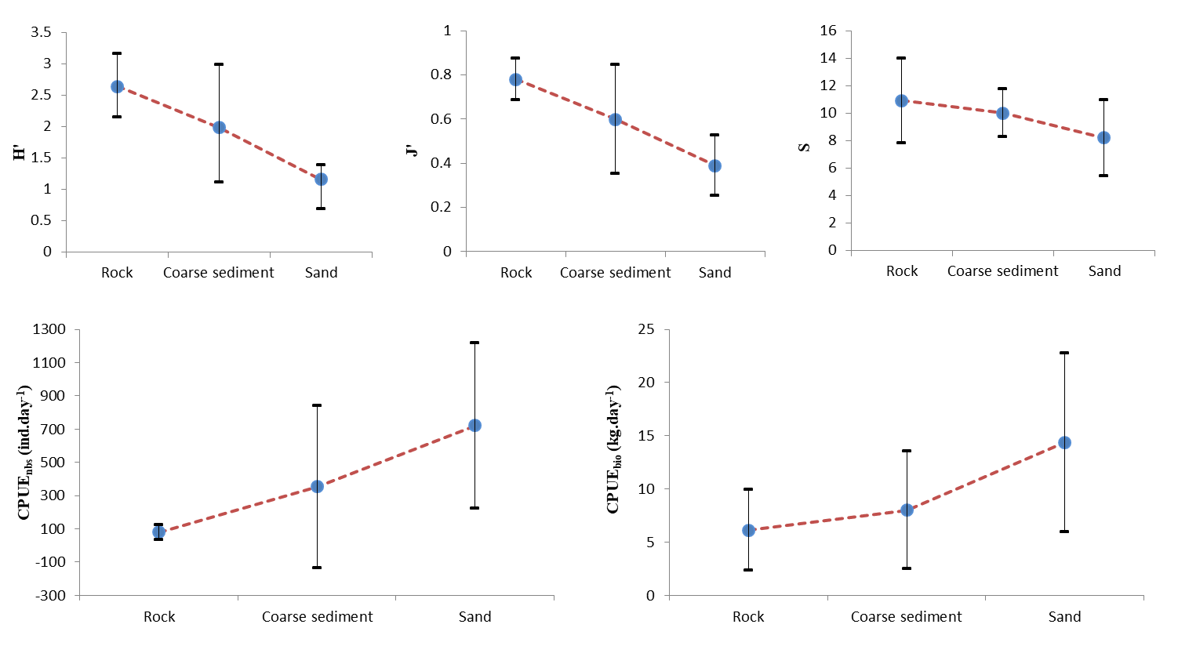
Figure 2. Mean diversity indices: Shannon – Wiener diversity (H’), evenness (J’); number of species (S); and Catch per unit effort data: in number (CPUE_{nbs}) and in biomass (CPUE_{bio}) by habitat type. Bars indicate the standard deviations of the estimated indices.

The community on coarse sediments (patchwork of boulders, gravels and sand) showed medium diversity (H’, J’, S) among the three habitats types – Figure 2. The dominant fish species on coarse sediments were M. batrachocephalus, M. barbatus, P.lascaris, P. cephalargoides and S. porcus, and from mobile epibenthos - L. vernalis, X. poressa and L. navigator.
The results for the sandy bottom demonstrated the lowest community species richness (S), diversity (H’) and evenness (J’). The typical species for sandy bottom were the crab L. vernalis, sand sole (P. lascaris), the stargazer (U. scaber), the greater weever (T. draco) and the whelk (R. venosa).
The diversity metrics and CPUE were compared among the habitats using the one-way ANOVA and Tukey HSD test. Significant effect of the habitat type was observed between rocky and sandy bottoms, which had statistically different diversity (H’, p < 0.0007), evenness (J’, p < 0.0004) and CPUE_{nbs} (p < 0.007). The sand community was strongly dominated by few species, reflected in the lowest J’ (Fig. 2). The coarse sediments did not show significant difference in terms of diversity indices and CPUE from the other two, possibly due to being inhabited by mixed communities.
The similarity analyses revealed clear community difference between sandy and rocky habitats, while there was no differentiation related to the depth changes within the habitats (Figure 3). The classification and ordination analyses differentiated two major clusters associated with the rocky (13 sites) and sandy habitat types (5 sites). Within each cluster there were sampling sites on shelly coarse substrate with mixed species composition (Figure 3). SIMPER analysis (Table 2) revealed similarity within the rocky group habitats of 40.44 % and for the sandy habitats - 61.86%, respectively. ANOSIM analyses confirmed that there is statistically significant strong correlation between species composition and habitat type (R=0.873, p<0.001), but do not detect correlation between communities according to the depth groups (R=0.092, p<0.001).

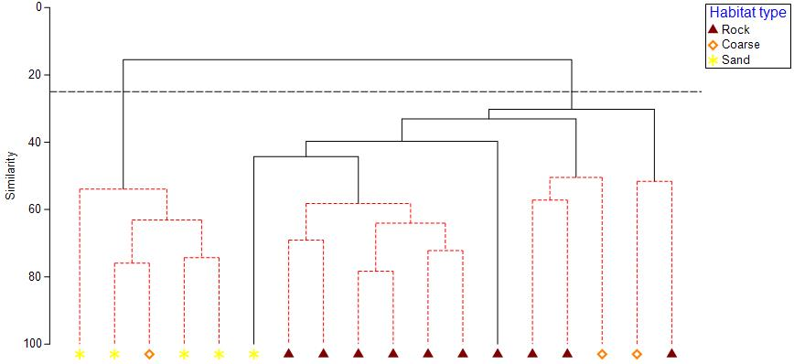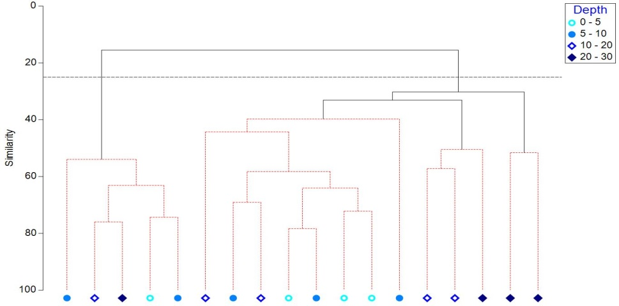

Figure 3. Hierarchical cluster analysis based on abundance data of bentho-pelagic fish and the mobile benthic epifauna in SAC Ropotamo in relation to the habitat type and depth range.

Table 2. SIMPER analysis of species mostly contributing to within-group average similarity of communities within SAC Ropotamo. Av.SIM: Average similarity, Av.abund – average species abundance, Cum.%: Cumulative percentage contribution to the group similarity.

Group Rock |  |  |  | Group Sand
Av. SIM = 40.44 |  |  |  | Av. SIM = 61.86
Species | Av.Abund | Av.Sim | Cum.% | Species | Av.Abund | Av.Sim | Cum.%
E. verrucosa | 3.2 | 6.2 | 15.33 | L. vernalis | 23.83 | 38.54 | 62.31
P. marmoratus | 3.17 | 5.33 | 28.50 | P. lascaris | 11.01 | 14.31 | 85.44
M. batrachocephalus | 1.95 | 4.75 | 40.26 | R. venosa | 4.74 | 4.67 | 92.99
S. porcus | 2.12 | 4.73 | 51.95 | U. scaber | 1.75 | 1.99 | 96.20
R. venosa | 2.41 | 2.86 | 59.02 | T. draco | 1.40 | 0.79 | 97.48
P. cephalargoides | 1.38 | 2.65 | 65.58 | E. verrucosa | 0.74 | 0.37 | 98.08
X. poressa | 1.08 | 2.52 | 71.81 | E. encrasicolus | 0.66 | 0.37 | 98.68
P. sanguinolentus | 1.67 | 2.34 | 77.61 | M.barbatus | 0.95 | 0.36 | 99.26
N. melanostomus | 1.2 | 2.14 | 82.91 | S. maximus | 0.48 | 0.25 | 99.67
G. mediterraneus | 0.78 | 1.35 | 86.25 | S. porcus | 0.71 | 0.21 | 100
P. lascaris | 0.74 | 1.33 | 89.54
M. barbatus | 0.74 | 1.16 | 92.40
S. roissali | 0.92 | 1.04 | 94.96
L. vernalis | 1.35 | 0.95 | 97.30

Non-metric Multi-Dimensional Scaling (MDS) was applied to data based on the average Bray-Curtis similarity between all pairs of stations. MDS ordination (3D stress = 0.07) in relation to the habitat type show clear divergence of communities on rocky and sandy bottoms (Fig. 4). Typical species for rocky habitats from fishes are Gobiids - M. batrachocephalus, P. cephalargoides, N. melanostomus and from other families - S. porcus, S. roissali, P. sanguinolentus. Crustacean are presented by E. verrucosa, P. marmoratus, X. poressa and L. vernalis and mollusks – by R. venosa. On sandy habitats, the most common species are fishes P. lascaris, U. scaber and T. draco, from crustaceans – L. vernalis, E. verrucosa and from molusks – R. venosa.

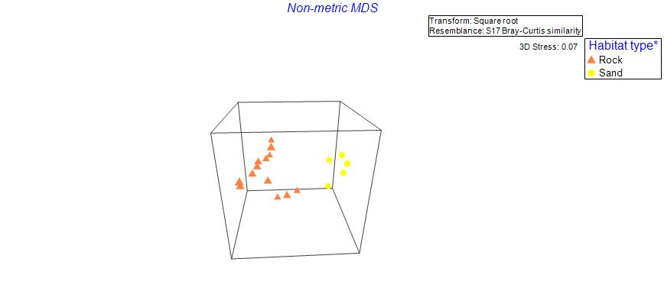
Figure 4. Three-dimensional MDS ordination based on abundance data of bentho-pelagic fish and the mobile benthic epifauna in SAC Ropotamo in relation to the habitat type.

RDA

The highest mean CPUE values of total bentho-pelagic fish and the mobile benthic epifauna number and biomass was recorded on the sandy bottoms (CPUE_{nbs} = 720.98 ind.day-1, CPUE_{bio} = 14.37 kg.day⁻¹) (Figure 2). The major share in total number and biomass in stations, located on sandy bottoms was due to the highly abundant P. lascaris and L. vernalis. CPUEbio on the coarse sediments was also high – 8.00 kg.day⁻¹ owing to P. lascaris and R. venosa. On the rocky bottoms, the single biomasses of E. verruccosa, S. porcus and P.marmoratus contribute to 65% of the similarity in this habitat. Tukey tests showed that the average CPUE_{nbs} and CPUE_{bio} of communities on sandy and rocky bottoms were significantly different (p < 0.005, p < 0.04).

4. Discussion
Alterations and diversity in habitat structure or depth range commonly result in shifting of food resources productivity and significantly influence the community structure, especially of the mobile component of the fauna – fish and invertebrates. Fish and invertebrates community structure depending on the habitat type is poorly investigated along the Bulgarian Black Sea coast, including the designated marine NATURA 2000 sites. The fauna diversity in SAC Ropotamo is still not well documented, but the area represents high scientific and conservation interest due to the variety of protected habitats present, and the occurrence of rare and threatened species. Natural habitats 1110 Sandbanks which are slightly covered by sea water all the time, 1170 Reefs and Shad species (Alosa immaculata, Alosa tanaica) are subject of conservation in SAC Natura "Ropotamo" (BG0001001). The protected area was declared for the purpose of conservation and maintenance of natural types of habitats, the habitats of the protected species, their populations and distribution within the boundaries of the area, for achieving and maintaining their favourable conservation status in the Black Sea bio-geographical region. In the marine aquatory, only the use of bottom trawls and dredges, disposal of dredged masses, ship ballast waters and construction of artificial underwater reefs and islands on the habitats subject to conservation are prohibited within the boundaries of the protected area. In the study area, despite its limited size and depth range, high number of species was recorded. The species list included 23 fish species, corresponding to the 18.25% of the total number of fish species (n = 126), reported by Prodanov et al. (1993) for the Bulgarian Black Sea coast and 7 crustacean and 2 mollusc species. The results of the present research suggest that high diversity was correlated to the rocky and coarse sediment habitat types, possibly due to the availability of diverse microhabitats such as rocky outcrops covered by macrophytes, sponges and mussels, pebbles, shelly gravel, overhangs, caves and cavities, that provide abundant shelter, food resources and nesting sites for variety of fish, crustacean and mollusc species. According to Todorova et al. (2009), SAC Ropotamo features a unique for the European seas habitat - Ostrea edulis biogenic reefs, which are inhabited by rare marine fauna with Ponto-Caspian and Mediterranean origin.
Clear difference in the bentho-pelagic fish assemblages and the mobile benthic epifauna communities was observed depending on the habitat substrate type and complexity. The structural complexity of rocky or coarse substrates supported a greater diversity of species (8 – 14 species) than the relatively more homogeneous habitats as sandy bottoms (5 – 12 species). Diversity metrics showed that the communities on rocky habitats attained the highest average species richness, high diversity and high evenness in the populations’ abundance. The typical fish species S. porcus, M. batrachocephalus, P. sanguinolentus, P. cephalargoides, S. roissali, and G. mediterraneus are non-migratory bottom dwellers and have preferences to rocky habitats. Most of them have territorial behaviour and could be found motionless between boulders, pebbles or algae, but they are capable to move over long distances. Mobile invertebrates E. verrucosa and P. marmoratus live among the stones and seaweeds along rocky coasts and the presence of mollusc R. venosa is possibly related to the species reproduction process, which requires availability of hard substrate needed for the attachment of egg masses (ICES 2004).
Lower diversity of the sandy bottom community was probably related to the simplicity of the substrate that limits the availability of shelters for the resident organisms. The majority of the inhabitants take cover in the sand to ambush prey (e.g. P. lascaris, T. draco and U. scaber) or represent benthophagous organisms (e.g. M. barbatus, gobiids). Sandy bottom communities were dominated by P. lascaris from the fishes, L. vernalis from the crustaceans and R. venosa from the molluscs, which reached high values of abundances and biomasses.
The results indicate that the substrate type was the determining factor responsible for the structuring of fish and invertebrate fauna assemblages, while the depth, possibly due to limited depth variation in this study, had lower ecological significance (Figure 3).
Да коментираме в дискусията, че съставът на обществото зависи от субстрата, вероятно във връзка с хранителните отношения, но не зависи от дълбочината, вероятно поради голямата мобилност на видовете.
The highest CPUE in terms of abundance was recorded on sandy bottoms probably because within a habitat the structure of the community is well defined and stable, including mostly non-migratory species. The lowest values were recorded on rocky bottoms.
It is very important that future investigations of fish and invertebrate fauna in NATURA 2000 site Ropotamo target each component of the assemblage of the habitat sampled. This will require multiple-gear sampling design aimed to quantitative assessment of the species inhabiting all types of habitats at seasonal scale. Studies of factors regulating species diversity within habitats is essential for understanding of ecosystem functioning and for more effective protection of the species and habitats.
The present study is the first attempt to examine the habitat-associated effects on the bentho-pelagic fish and the mobile benthic epifauna communities in the coastal Bulgarian Black Sea. Our findings indicate clear differentiation of habitat type-specific assemblages, significantly different in composition and structure, abundance and biomass of the species. The study results provide a baseline for future monitoring of the effect of the marine protected area on fish and invertebrates conservation status.

5. Conclusions
This section is not mandatory but can be added to the manuscript if the discussion is unusually long or complex.

Author Contributions: For research articles with several authors, a short paragraph specifying their individual contributions must be provided. The following statements should be used “Conceptualization, X.X. and Y.Y.; methodology, X.X.; software, X.X.; validation, X.X., Y.Y. and Z.Z.; formal analysis, X.X.; investigation, X.X.; resources, X.X.; data curation, X.X.; writing—original draft preparation, X.X.; writing—review and editing, X.X.; visualization, X.X.; supervision, X.X.; project administration, X.X.; funding acquisition, Y.Y. All authors have read and agreed to the published version of the manuscript.” Please turn to the CRediT taxonomy for the term explanation. Authorship must be limited to those who have contributed substantially to the work reported.
Funding: This research was funded by European Community’s Seventh Framework Programme (FP7/2007-2013), Grant Agreement No. 287844 for the project ‘Towards COast to COast NETworks of marine protected areas (from the shore to the high and deep sea), coupled with sea-based wind energy potential’ (COCONET) and BLUECRISTAL.
Data Availability Statement: We encourage all authors of articles published in MDPI journals to share their research data. In this section, please provide details regarding where data supporting reported results can be found, including links to publicly archived datasets analyzed or generated during the study. Where no new data were created, or where data is unavailable due to privacy or ethical restrictions, a statement is still required. Suggested Data Availability Statements are available in section “MDPI Research Data Policies” at https://www.mdpi.com/ethics.
Acknowledgments: In this section, you can acknowledge any support given which is not covered by the author contribution or funding sections. This may include administrative and technical support, or donations in kind (e.g., materials used for experiments). Where GenAI has been used for purposes such as generating text, data, or graphics, or for study design, data collection, analysis, or interpretation of data, please add “During the preparation of this manuscript/study, the author(s) used [tool name, version information] for the purposes of [description of use]. The authors have reviewed and edited the output and take full responsibility for the content of this publication.”
Conflicts of Interest: The authors declare no conflicts of interest

Abbreviations
The following abbreviations are used in this manuscript:
MDPI | Multidisciplinary Digital Publishing Institute
DOAJ | Directory of open access journals
TLA | Three letter acronym
LD | Linear dichroism

Appendix A

Appendix A.1
The appendix is an optional section that can contain details and data supplemental to the main text—for example, explanations of experimental details that would disrupt the flow of the main text but nonetheless remain crucial to understanding and reproducing the research shown; figures of replicates for experiments of which representative data is shown in the main text can be added here if brief, or as Supplementary data. Mathematical proofs of results not central to the paper can be added as an appendix.

Appendix B
All appendix sections must be cited in the main text. In the appendices, Figures, Tables, etc. should be labeled starting with “A”—e.g., Figure A1, Figure A2, etc.

References
References must be numbered in order of appearance in the text (including citations in tables and legends) and listed individually at the end of the manuscript. We recommend preparing the references with a bibliography software package, such as EndNote, ReferenceManager or Zotero to avoid typing mistakes and duplicated references. Include the digital object identifier (DOI) for all references where available.

Citations and references in the Supplementary Materials are permitted provided that they also appear in the reference list here.

In the text, reference numbers should be placed in square brackets [ ] and placed before the punctuation; for example [1], [1–3] or [1,3]. For embedded citations in the text with pagination, use both parentheses and brackets to indicate the reference number and page numbers; for example [5] (p. 10), or [6] (pp. 101–105).

- Jennings, S.; Kaiser, M.J. The effects of fishing on marine ecosystems. Advances in Marine Biology 1998, 34, 201–352.
- Jackson, J.B.; Kirby, M.X.; Berger, W.H.; Bjorndal, K.A.; Botsford, L.W.; Bourque, B.J.; Bradbury, R.H.; Cooke, R.; Erlandson, J.; Estes, J.A.; Hughes, T.P.; Kidwell, S.; Lange, C.B., Lenihan, H.S.; Pandolfi, J.M.; Peterson, C.H.; Steneck, R.S.; Tegner, M.J.; Warner, R.R. Historical overfishing and the recent collapse of coastal ecosystems. Science 2001, 293(5530), 629-37.
- Zaitsev, Yu.; Mamaev, V. Marine biological Diversity in the Black Sea. A study of change and decline. Black sea Environmental Series. 3, UN Publ., New York, USA, 1997, 208 p.
- Vinogradov, M.E.; Sapoznikov, V.V., Shushkina, E.A. The Black Sea Ecosystem. Publisher: Nauka, Moscow, 1992, 112 p.
- Prodanov et al. 1997
- BSC 2008

- Author 1, A.B.; Author 2, C.D. Title of the article. Abbreviated Journal Name Year, Volume, page range.
- Author 1, A.; Author 2, B. Title of the chapter. In Book Title, 2nd ed.; Editor 1, A., Editor 2, B., Eds.; Publisher: Publisher Location, Country, 2007; Volume 3, pp. 154–196.
- Author 1, A.; Author 2, B. Book Title, 3rd ed.; Publisher: Publisher Location, Country, 2008; pp. 154–196.
- Author 1, A.B.; Author 2, C. Title of Unpublished Work. Abbreviated Journal Name year, phrase indicating stage of publication (submitted; accepted; in press).
- Author 1, A.B. (University, City, State, Country); Author 2, C. (Institute, City, State, Country). Personal communication, 2012.
- Author 1, A.B.; Author 2, C.D.; Author 3, E.F. Title of Presentation. In Proceedings of the Name of the Conference, Location of Conference, Country, Date of Conference (Day Month Year).
- Author 1, A.B. Title of Thesis. Level of Thesis, Degree-Granting University, Location of University, Date of Completion.
- Title of Site. Available online: URL (accessed on Day Month Year).
Disclaimer/Publisher’s Note: The statements, opinions and data contained in all publications are solely those of the individual author(s) and contributor(s) and not of MDPI and/or the editor(s). MDPI and/or the editor(s) disclaim responsibility for any injury to people or property resulting from any ideas, methods, instructions or products referred to in the content.

